User Stories for analyzing Copy Number

Phase 1 GISTIC interaction

- User wants to add a criterion to a compound query and use only the amplified genes from a gene pattern GISTIC job result. In the “Gene Picker”, in the Gene Lists popup, the USBAT see the gene lists from their GISTIC job results. USBAT save this query.
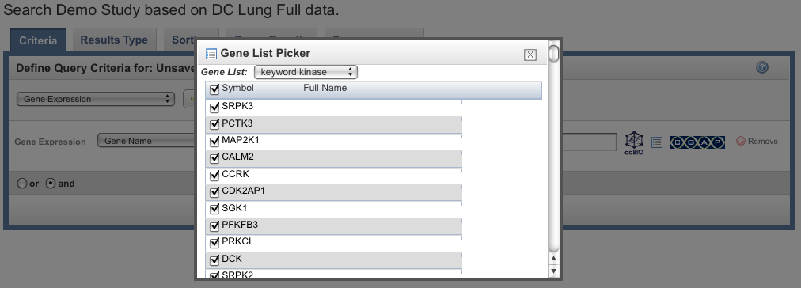
- User wants to add a criterion to a compound query, and use only the deleted genes from a gene pattern GISTIC job result. In the “Gene Picker”, in the Gene Lists popup, the USBAT see the gene lists from their GISTIC job results. USBAT save this query.
++++++++

